Syeda Reeha Quasar

14114802719

3C7

Experiment - 6

Switching Theory and Logic Design (STLD)

Aim

To realize priority encoder using basic Gates.

# **EXPERIMENT - 6**

## **AIM:**

To realize priority encoder using basic Gates.

## **Hardware and Software Apparatus Required**

Hardware:

Breadboard, IC 7408 (AND), IC 7404(NOT), IC 7432(OR), LEDs, 5V power supply, connecting wires.

* Power supply, Bread Board, Connecting Wires, respective IC, LED, Wire Cutter.
* Circuit is designed on bread board using Integrated Chips (ICs), Voltage supply and LEDS.
* The set-up of apparatus and working of the circuit were demonstrated via recorded videos.

Software Simulation:

The schematic models of the desired circuits will be stimulated on MULTISIM (Free Software), easily accessible at [www.multisim.com](http://www.multisim.com).

Components used – Source (Clock Voltage), Passive elements (resistor), Digital components (AND, OR, NAND, NOR, XOR, XNOR, Inverter), Probe for Analysis and annotation (Digital), Schematic connectors (Ground)

## **Theory:**

The priority encoder is an encoder circuit that includes the priority function. The operation of priority encoder is such that if to or more inputs are equal to 1 at the same time the input having the highest priority will take precedence. The 4-input priority encoder has 4 inputs and 3 outputs. ‘V’ is a valid-bit indicator that is set to 1 when one or more inputs are equal to 1. If all inputs are zero, there is no valid input and V is equal to 0. The other two outputs are not inspected when V equals 0 and are specified as don’t care conditions.

## 

## 

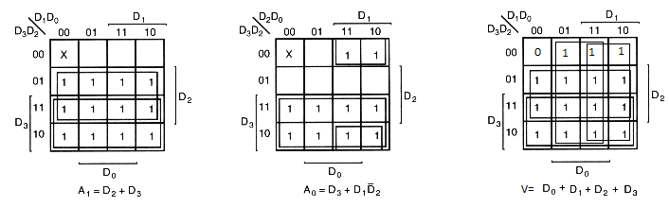

Fig 4.1 Logic diagram along with K-Map minimization

## **Procedure followed on MULTISIM:**

* Check all the components for their working.
* Insert the appropriate IC into the IC base.
* Make connections as shown in the logic diagram.
* Verify the results and observe the outputs.

## **PRECAUTIONS:**

All ICs should be checked before starting the experiment.

1. All the connection should be tight.
2. Always connect ground first and then the supply.
3. Switch off the power supply after completion of the experiment.

## **RESULT:**

Priority Encoder has been studied and its truth table has been verified.

**Circuits and Output waveform**

## **Priority Encoder**

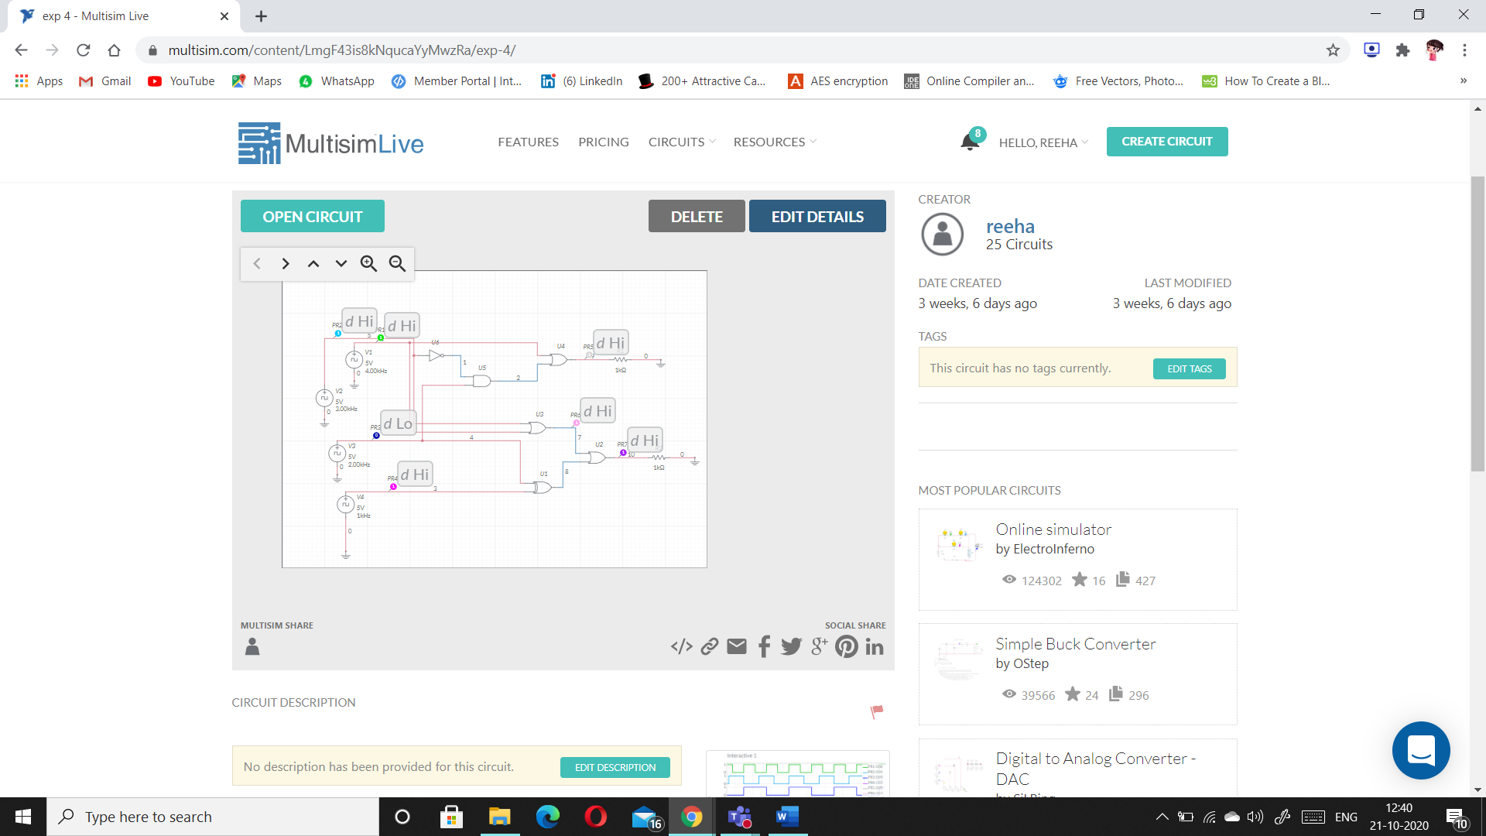

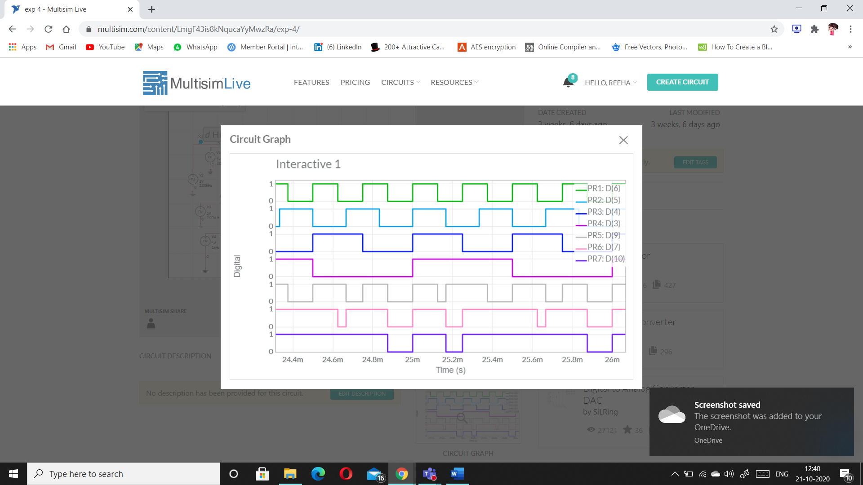

# **VIVA-VOCE QUESTIONS:**

1. **What is an encoder?**

Ans.

An encoder in digital electronics is a one-hot to binary converter. That is, if there are 2ⁿ input lines, and at most only one of them will ever be high, the binary code of this 'hot' line is produced on the n-bit output lines. A binary encoder is the dual of a binary decoder.

1. **State the difference between simple encoder and priority encoder.**

Ans.

An ordinary encoder has a number of input lines but only one of them is activated at a given time. A priority encoder can have more than one input activated at the same time.

Binary Encoder converts one of 2n inputs into an n-bit output. It has fewer output bits than the input code. The Priority Encoder is another type of combinational circuit similar to a binary encoder, except that it generates an output code based on the highest prioritized input.

1. **Specify the applications of Encoder and decoder.**

Ans.

* Speed synchronization of multiple motors in industries
* War field flying robot with a night vision flying camera
* Robotic vehicle with the metal detector
* RF based home automation system
* Automatic health monitoring systems

1. **How an encoder is different from a multiplexer?**

Ans.

A multiplexer or MUX is a combination circuit that contains more than one input line, one output line and more than one selection line. Whereas, an encoder is also considered a type of multiplexer but without a single output line. It is a combinational logic function that has 2^n (or fewer) input lines and n output lines.